Lab 08

Dasanayaka D.M.H.N.A.

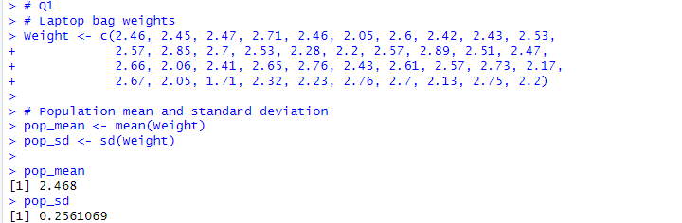1)

2)

3)

